Precalculus/Trig 3 Name ____________________________________

Conic Sections: Parabolas

Conic Sections

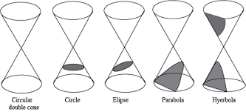

How to tell which conic you are working with based on its equation…

When the equation is equal to zero, ask yourself:

1. Is there more than one squared term?

NO – Parabola YES – Go on to question 2

1. Do the squared terms both have the same sign?

NO – Hyperbola YES – Go on to question 3

1. Are the coefficients in front of the squared terms the same?

NO – Ellipse YES - Circle

Examples:

Classify each of the following equations as the equation of a parabola, ellipse, circle, or hyperbola.

1. 
2. 
3. 
4. 

Parabola:

Vertex:

Axis:

Standard Form:

# Changing from the general form to standard form for a parabola

Completing the square:

Example: Steps:

1.  1.

2.

3.

4.

5.

2. 

Finding the Focus of a Parabola:

1. Covert to standard form by completing the square

2. Identify the vertex

3. Solve for “p”

4. Decide if the parabola opens up/down or left/right based on “p”

5. Add “p” to the appropriate coordinate

Examples:

Find the vertex, focus, and directrix of each parabola and sketch its graph.

1. 

2. 

3. 

Find the standard form of the equation of a parabola with the given characteristics.

1. Vertex: (-1, 2) Focus: (-1,0)

2. Vertex: (0, 2) Directrix: x = -3

3. Focus: (0, 0) Directrix: y = 8